|  |
| --- |
|  |
| Faculty of Computers and Information Technology (FCIT) |
| Auto-attendance  Supervisor: Dr Mohammad Naif Al-Atawi  Authors:  Mazen Mohsen Tohari 411003806  Abdulrhman Saeed Alshahrani 411004826  Ahmed Marzuq Alanzy 391002020  Thamer Thib Alanazi 411005223  Abdulmohsen Mohammed Alblawi 371000352  Rayed Alzahrani 397100641 |
| Submitted in partial fulfilment of the requirements for the Degree of Bachelor of Computer Science |
| Academic Year: 2022/23 |

**Declaration of Originality**

Except as properly recognized, this project is entirely my own original work. No portions or all of it have been taken from any other sources. As a result, all references to previously published material (found in books, journals, magazines, the internet, etc.) have been acknowledged and linked to a reference item in the main report.

I consent to the storage and use of an electronic copy of this report for the purposes of preventing and detecting plagiarism.

I am aware that cheating and plagiarism are violations of university policies and will be dealt with as such.

Signed: Date:

**Office Stamp**

**Copyright**

The copyright of this project and report belongs to the University of Tabuk.

# Abstract

It is a smartphone software whose main objective is to facilitate various tasks that used to take both the student and the lecturer a lot of time. Knowing where the halls and teachers are for each institution and lecture to make it easier for attendees to arrive by taking the quickest route to the hall or being connected to the professors' offices Every student has the UniFinder app, and each lecture hall has an Ibeacon with the lecture information and lecturer's hall number added to the student's calendar.

# Table of Contents

**Abstract 3**

**Table of Contents 4**

**Additional Materials on the Accompanying CD 5**

**List of Table 6**

**List of Figures 7**

**List of Abbreviations 8**

**Acknowledgements 9**

1. **Introduction 10**
   1. **Background to the Project 10**
   2. **Project Objectives 10**
   3. **Aims and Objectives 10**

**1.3.1** **Advantage 10**

**1.3.2** **Drawback 11**

1. **Investigation 12**
   1. **Where's my Staff 12**
   2. **TimeCamp 13**
   3. **Bonsai 13**
   4. **Odoo 14**
   5. **Menaitech 14**
2. **Methodology 16**
3. **Requirements 17**
   1. **Functional Requirements 17**
   2. **Non-Functional Requirements 18**
4. **Analysis 19**
   1. **Use Case Diagram 19**
   2. **Sequence Diagram 20**
   3. **Activity Diagram 21**
5. **Design 22**
   1. **Entity Relationship Diagrams 22**
   2. **Data Dictionary Design 23**

**7** **Bibliography and References 25**

## Additional Materials on the Accompanying CD

|  |  |  |  |
| --- | --- | --- | --- |
| **List of Table** |  | | |
| **TABLE** | **TITLE** | **PAGE** |  |
| Table 1. Comparison with related systems |  |  | 15 |
| Table 2. Admin |  |  | 23 |
| Table 3. Staff info |  |  | 23 |
| Table 4. Teacher |  |  | 23 |
| Table 5. Student |  |  | 23 |
| Table 6. Department |  |  | 23 |
| Table 7. Hall Details |  |  | 24 |
| Table 8. Hall |  |  | 24 |
| Table 9. Schedule |  |  | 24 |
| Table 10. Ibeacon |  |  | 24 |

# List of Figures

#### FIGURE TITLE PAGE

Figure 1. Where's my Staff website 12

Figure 2. TimeCamp website 13

Figure 3. Bonsai website 13

Figure 4. Odoo website. 14

Figure 5. Water Fall Stages 16

Figure 6. Ibeacon operation 17

Figure 7. use case Diagram 19

Figure 8. Sequence Diagram 20

Figure 9. Activity Diagram 21

Figure 10. ER Diagrams 22

# List of Abbreviations

CS Computer Science

# 

# 

# 

# 

# 

# 

# 

# 

# 

# 

# 

# 

# 

# 

# 

# 

# 

# 

# 

# 

# 

# 

# 

# 

# 

# 

# 

# 

# 

# 

# 

# 

# 

# Acknowledgements

We would like to express our gratitude to everyone who helped us complete this project successfully. Thank you, Dr. Muhammad Nayef Al-Atwi, our study supervisor, for his incredibly helpful direction, advice, and amazing patience during the course of the research process.

We also want to thank our parents and friends for their love and support, who aided and inspired us

# Introduction

In the beginning, let us review the problems, how much the Lecturer loses time for attending, and sometimes he mistakes another Student, but our project idea can solve it. What about the Students They mistake things that the project can solve, such as what is the proper hall and is that my Course; if the project has rich for the highest compilation, we can use it for things other than the university, such as Cafés, restaurants and touristic places, this project can have many ideas involving (area information, and sending it for the user).

## Background to the Project

Given the importance of time for the student and the teacher and to take the maximum educational attainment.

Our project focuses on saving time and facilitating many steps.

## Project Objectives

• Ease of attendance and absence

• Find out where the halls are

• Knowing where the teachers are

**Problem overview:**

* The college requires a method of tracking students' attendance and absences.
* It could be challenging for visitors, teachers, and students to locate the hallways.
* 5–10 minutes are lost as the teacher takes attendance.

**1.3 Aims and Objectives**

Therefore, we are working on an application for university students to facilitate the connection and save Time for students to find halls and teachers.

Auto-attendance and timer for the duration of the student's lecture attendance.

Our system will save the teacher and student time. Also, the conflict with Student's name will not be an issue.

**1.3.1** Advantages

• 1- Attendance and absence for all students automatically.

• 2- Temporary for the duration of the student's lecture attendance.

• 3- Hall status, is there a lecture or not.

• 4- Fetching the information of the current hall, for example (the lecturer, the Lecturer start timer)

• 5- Hall Lectures .

• 6- Print the student attendance record for only the lecturer.

1.3.2 Drawbacks

• The Cust of Ibeacon

• Does not specify the time if the Ibeacon didn't indicate the student.

• If the student has his phone turned off, then his absent.

• If the student has his phone turned off in the middle of class time, it will show less attendance time in state time.

## Overview of This Report

In addition to the current chapter, the report consists of nine other chapters:

* Chapter 2 presents the investigation.
* Chapter 3 presents the methodology.
* Chapter 4 presents the requirements.
* Chapter 5 depicts the analyses of the system.
* Chapter 6 describes the design of the system.
* Chapter 7 presents the implementation.
* Chapter 8 presents the conclusions.

# Investigation

We investigated many of the similar systems available on the web platform. We discovered several systems that offer a similar system tapproachrough the web platform—analysed based on the observation.

## Where's my Staff

Where’s My Staff is a smartphone app developed by Trigging Company to help managers keep track of their employees during working hours. Office spaces and buildings.

* advantages

1. Employee tracking
2. Know the office locations

* disadvantages

1. Absence and presence
2. For managers only

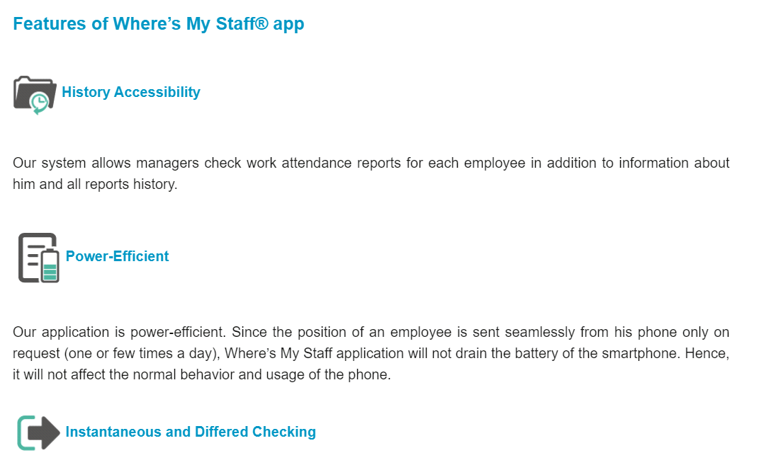

**Figure 1.** Where's my Staff

## TimeCamp

TimeCamp is an attendance and absence management application for staff and students

* advantages

1. Follow up attendance and absence
2. Attendance stats

* disadvantages

1. Know the locations of halls and offices
2. Absenteeism and preparation manually

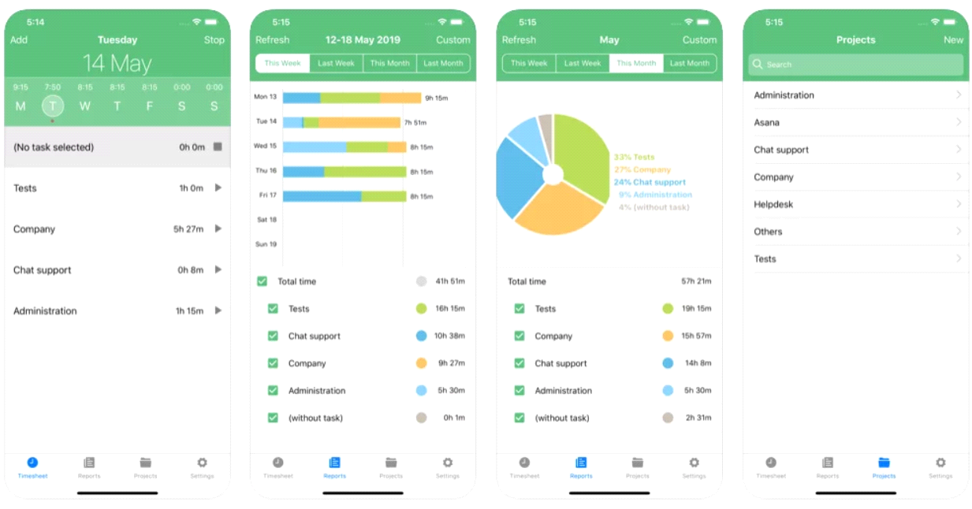

**Figure 2.** TimeCamp

## Bonsai

Bonsai is a set of tools for employees and company managers to manage and track attendance

* advantages

1. Easily track attendance

* disadvantages

1. For companies only
2. Office places or halls

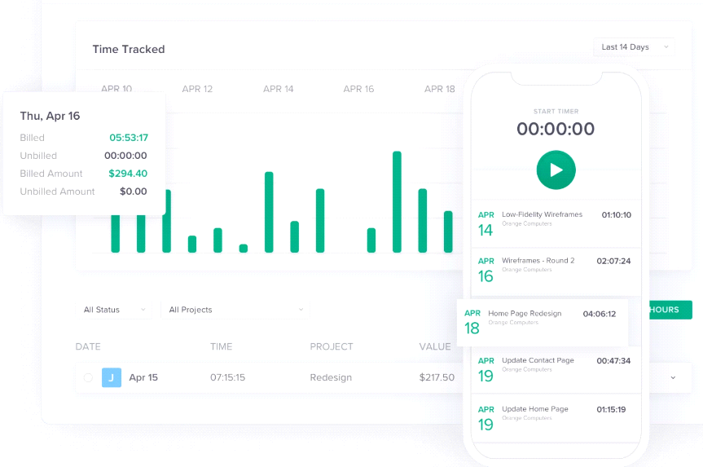

**Figure 3.** Bonsai

## 

## Odoo

Attendance management site and attendance statistics for employees and students

* advantages

1. Manage attendance efficiently and simply

* disadvantages

1. staff quarters
2. Hall locations

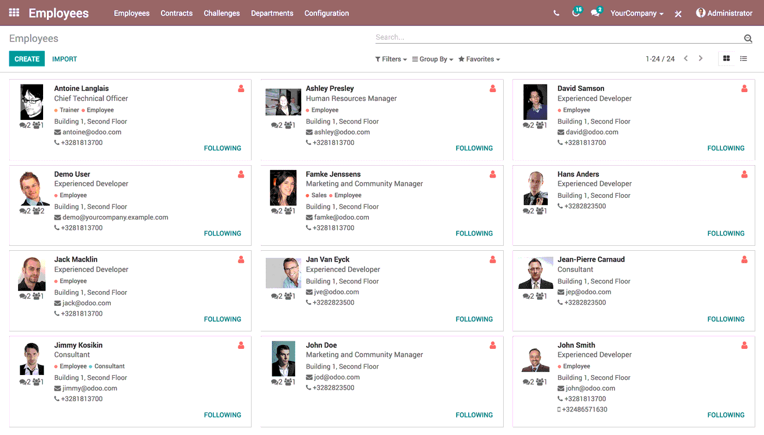

**Figure 4.** Odoo

## Menaitech

A site specialized in following up attendance and absence

* advantages

1. Manage attendance easily and effectively

* disadvantages

1. Adjust attendance times
2. Office or staff locations

**Table 1. Comparison with related systems**

|  |  |  |  |  |  |
| --- | --- | --- | --- | --- | --- |
| **Features** | **System** | | | | |
| Where's my Staff | **TimeCamp** | **Bonsai** | **Odoo** | **Menaitech** |
| **Web platform** | **✅** | **✅** | **✅** | **✅** | **✅** |
| **Free trial** | **❎** | **❎** | **✅** | **✅** | **✅** |
| **stability** | **✅** | **✅** | **✅** | **✅** | **✅** |
| **Arabic language** | **✅** | **❎** | **❎** | **✅** | **✅** |

# Methodology

Waterfall project management will be used. The waterfall technique is a project management strategy that places a focus on a straight line from the start to the finish of a project. This practice is frequently used by engineers, who are front-loaded to rely on careful planning, thorough documentation, and diligent execution.

The Waterfall process usually includes stages:

**Analysis:**

The Waterfall methodology is predicated on the idea that all project specifications can be acquired and comprehended in advance. The project manager makes every effort to fully comprehend the needs of the project sponsor. Each stage of the project is described in writing, typically in a single document, together with the costs, risks, assumptions, dependencies, success measures, and completion dates.

**Design:**

A technological solution to the issues outlined in the product requirements is created by software developers, including scenarios, layouts, and data models. A higher-level or logical design that outlines the project's goals, scope, general traffic patterns for each component, and interconnection points is first produced. Once finished, it is converted utilizing specialized hardware and software technologies into a physical design.

**Implementation:**

Once the design is complete, technical implementation starts. In this phase, programmers code applications based on project requirements and specifications, with some testing and implementation also taking place.

**Testing:**

Testing must ensure the product has no errors, and all requirements have been completed, providing a good user experience with the software. The testing team will turn to the design documents, personas, and user case scenarios supplied by the product manager to create their test cases.

**Maintenance:**

Once the software has been deployed in the market or released to customers, the maintenance phase begins. As defects are found, and change requests come in from users, a team will be assigned to take care of updates and release new software versions [5].

# Requirements

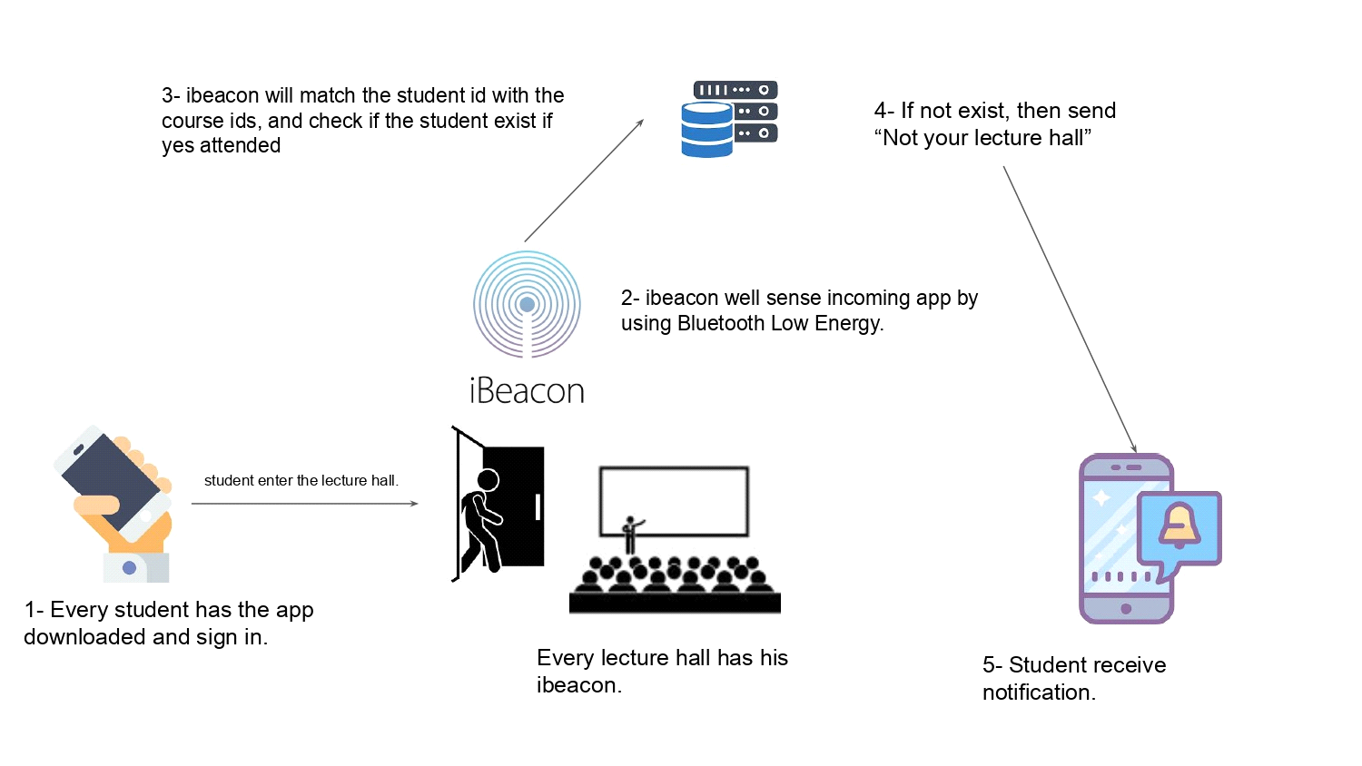

**Figure 6.** Ibeacon operation

## Functional Requirements

Functional requirements are product features or functions that developers must implement to enable users to accomplish their tasks. This system has many functions lecturers that assist clinics with their processes and management.

For the software:

* Administrator controls the accounts of the Lecturer and the Student (Create, Modify, Delete).
* Administrator controls the Lecturer and (Creates, Modify, and Delete).
* Administrator controls the student accounts (Create, Modify, Delete).
* Lecturer requests the auto-attendants.
* Lecturer requests to print the state of class (student’s attendance time, attendance and absence).
* Students request the hall name.

For the handwear:

* We will use it in our system Ibeacon device.

## Non-Functional Requirements

A non-functional requirement is a constraint or a requirement that the system is obligated to meet. Software quality attributes are specified in these documents. Scalability, maintainability, performance, portability, security, reliability, and many other non-functional requirements fall under these categories [10].

For the software:

We need to ask the company for permeation to find an Ibeacon device that allows us to program.

Connecting the Ibeacon to the system coding.

Connecting the Ibeacon to the database.

Building a server that holds all the students and lecturers.

For the hardware:

The cost of the Ibeacon that we need every hall to have.

Ibeacon sensor range.

In case of hardware errors, we need to buy a new Ibeacon.

Does the Ibeacon stay on for timing the student attended?

# Analysis

At this phase, we will use some of the Unified Modeling Languages (UML) in this project because of its great help in the analysis and documentation process. Using the schemes Case Diagram, Sequence Diagram, Activity Diagram and Class Diagram.

## Use Case Diagram

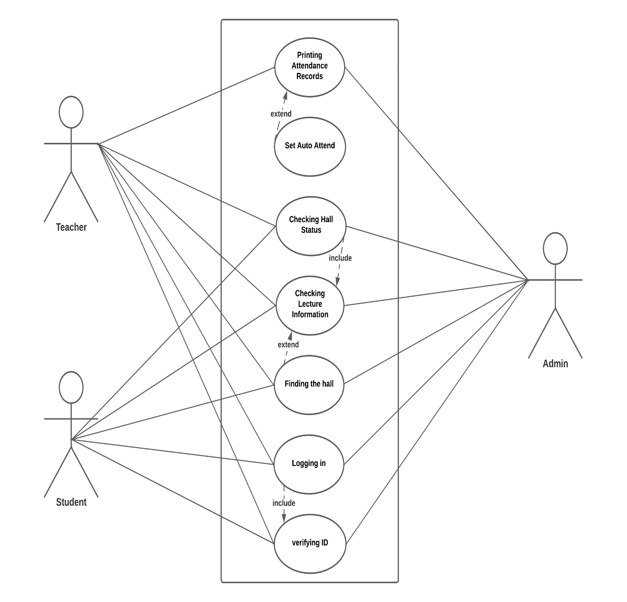

**Figure 7.** use case Diagram

## Sequence Diagram

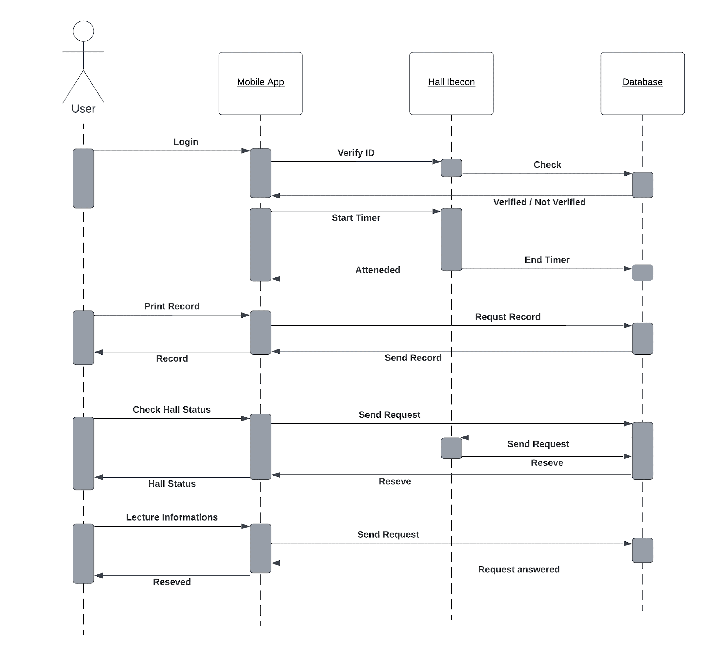

**Figure 8.** Sequence Diagram

## Activity Diagram

**1**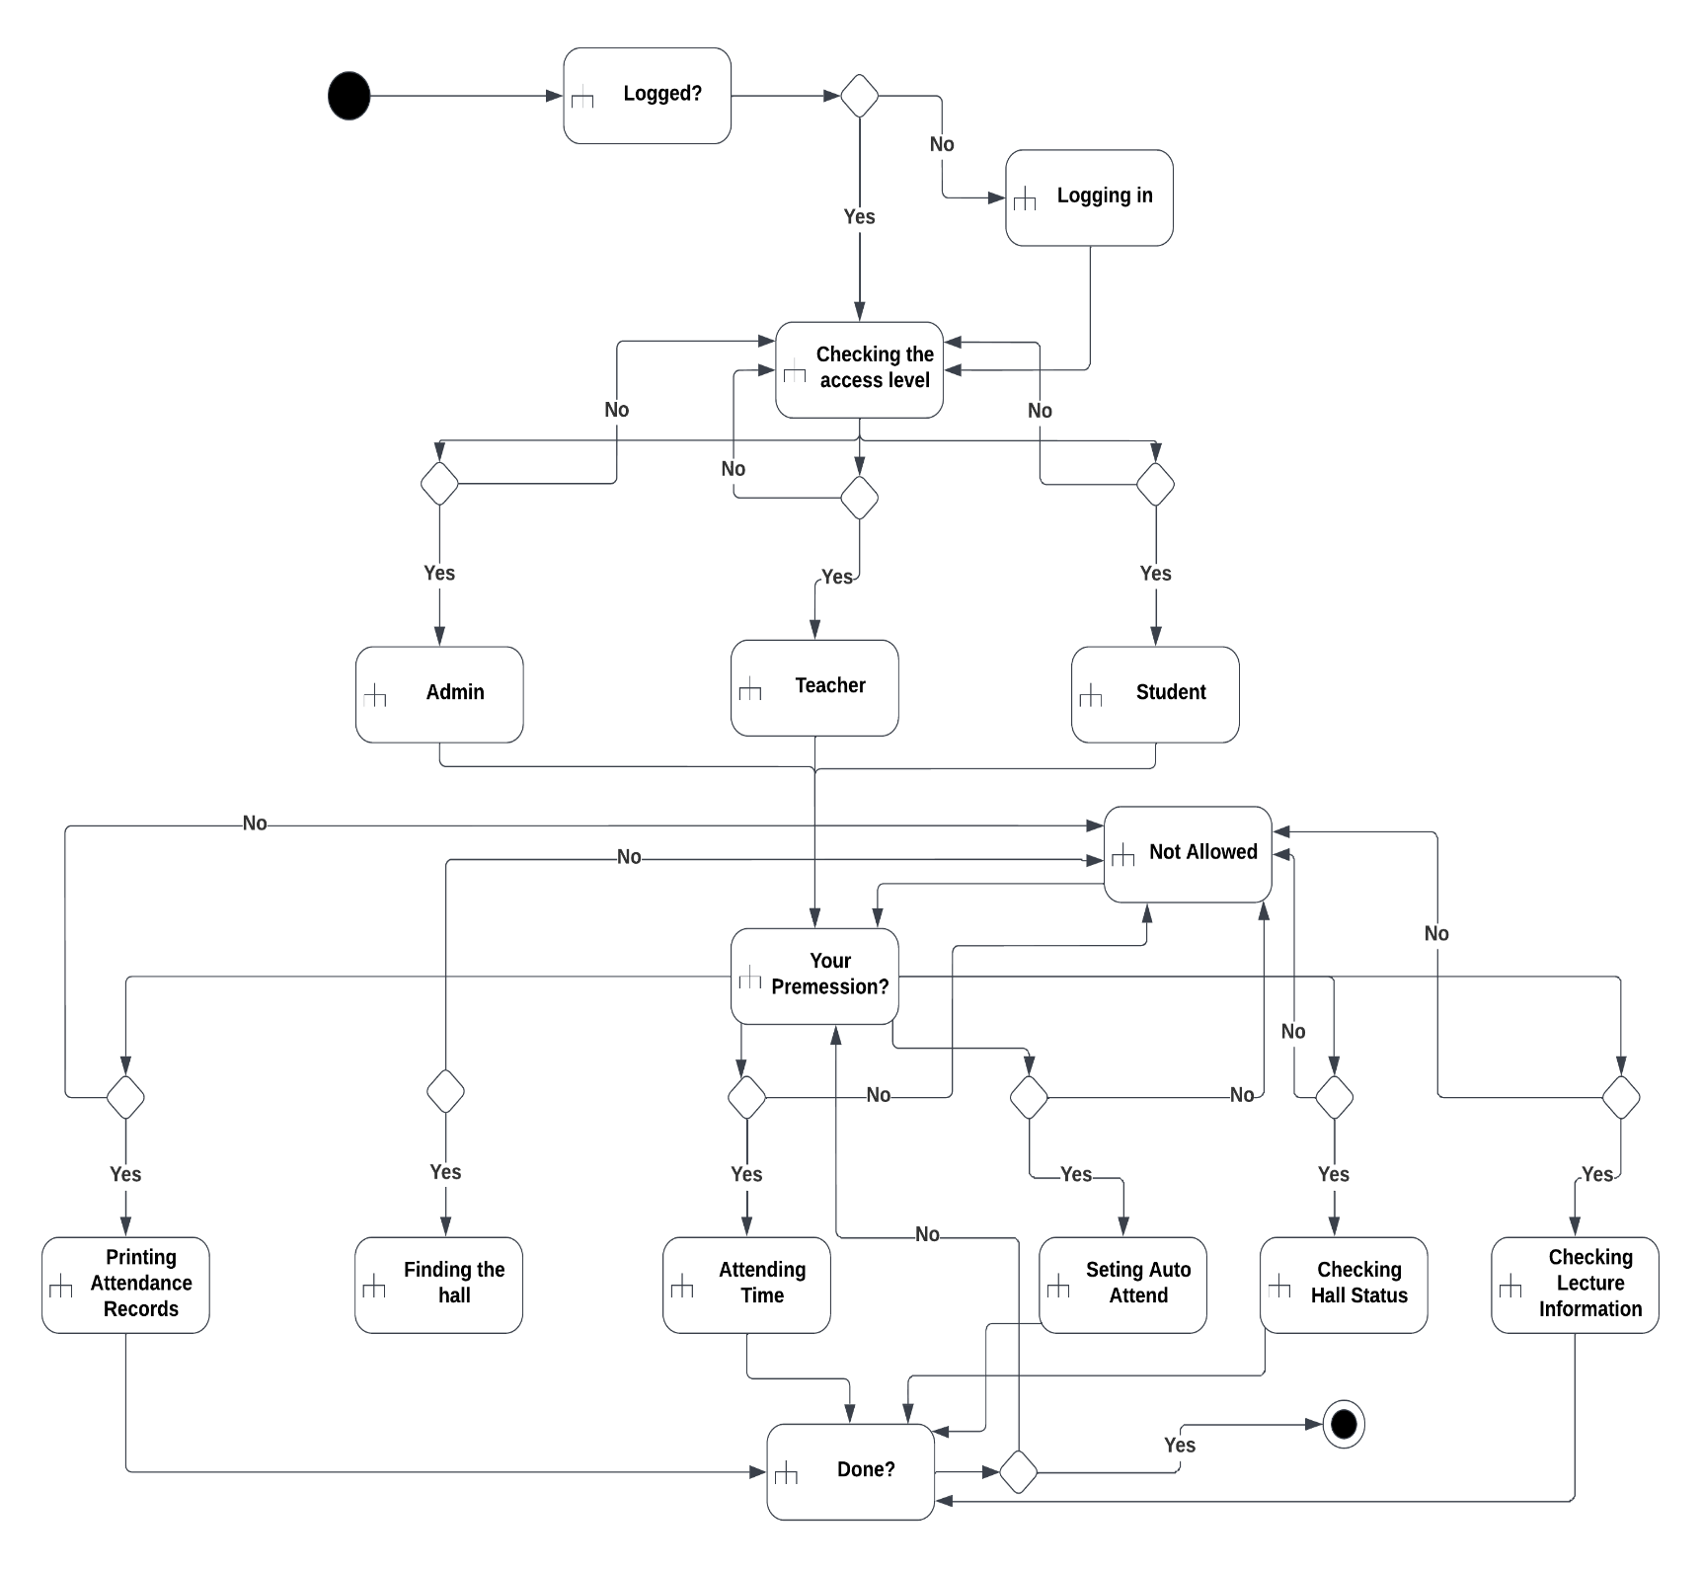

**Figure 9.** Activity Diagram

# Design

At this stage, we will present the entire system’s design through a diagram shown in the figure conceptual databases and relationships between objects in the system through the Entity Relationship Diagram (ERD).

## Entity Relationship Diagrams

An entity relationship diagram (ERD) shows the relationships of entity sets stored in a database [10].

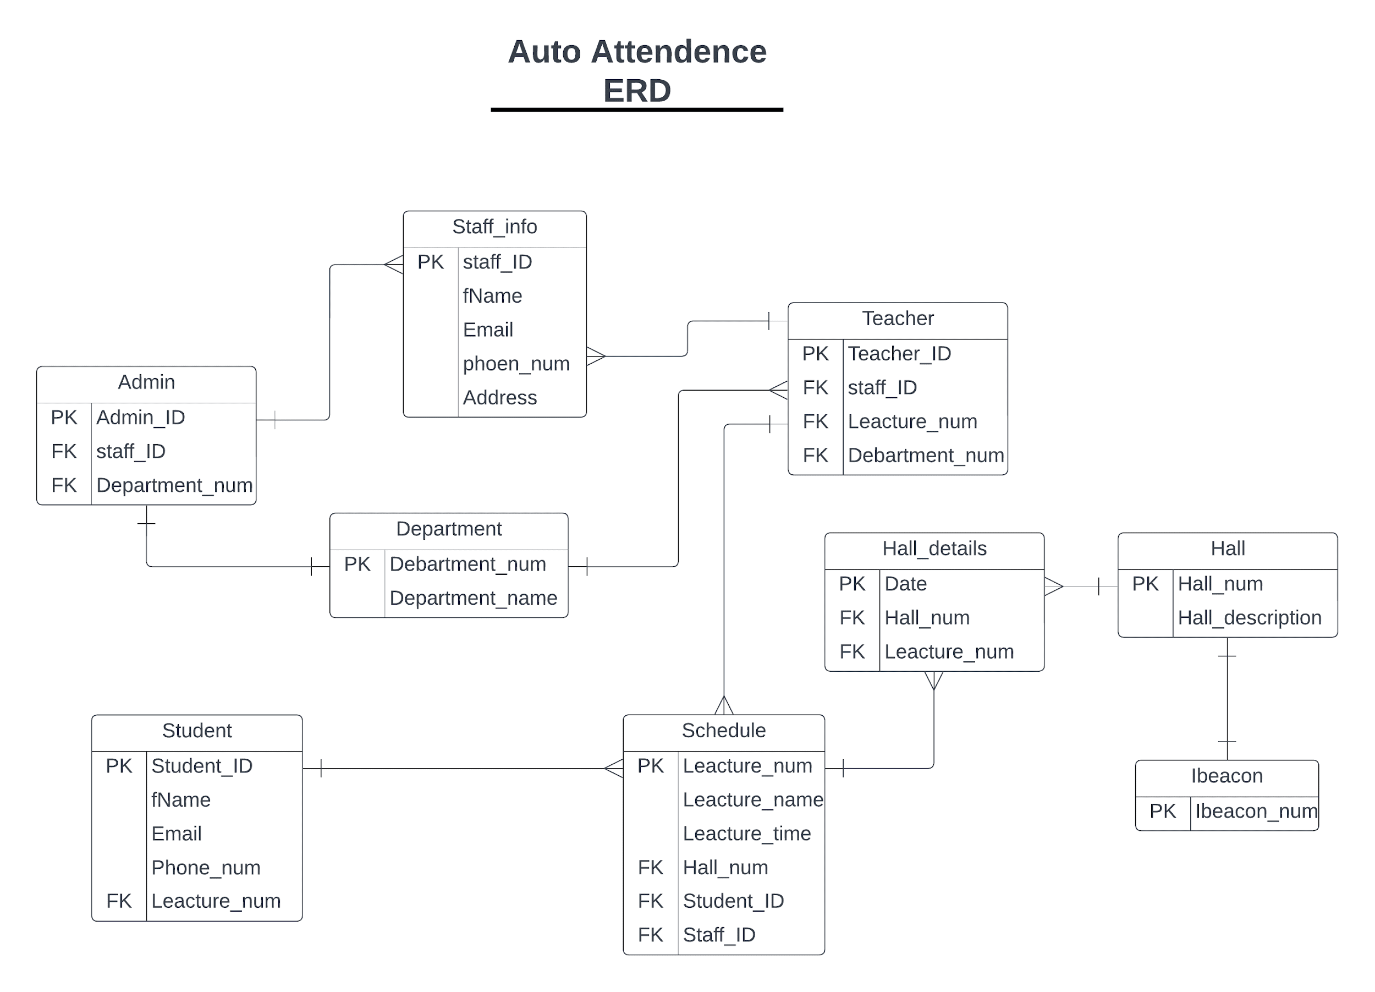

**Figure 10.** ER Diagrams

## Data Dictionary Design

The data dictionary is an inventory of data elements in a database or data model with a detailed description of its format, relationships, meaning, source and usage [7]. The data dictionary for the project is shown in the tables below.

**Table 2. Admin**

|  |  |  |
| --- | --- | --- |
| **Attribute** | **Type** | **Key** |
| Admin_ID | Int(7) | PK |
| Staff_ID | Int(10) | FK |
| Department_num | varchar(5) | FK |

**Table 11. Staff info**

|  |  |  |
| --- | --- | --- |
| **Attribute** | **Type** | **Key** |
| Staff_ID | Int(10) | PK |
| fName | varchar(50) |  |
| Email | varchar(25) |  |
| Phone_num | Int(10) |  |
| Address | Varchar(50) |  |

**Table 12. Teacher**

|  |  |  |
| --- | --- | --- |
| **Attribute** | **Type** | **Key** |
| Teacher_ID | Int(7) | PK |
| Staff_ID | Int(10) | FK |
| Leacture_num | varchar(7) | FK |
| Department_num | Int(5) | FK |

**Table 3. Student**

|  |  |  |
| --- | --- | --- |
| **Attribute** | **Type** | **Key** |
| Student_ID | Int(10) | PK |
| fName | varchar(50) |  |
| Email | varchar(25) |  |
| Phone_num | Varchar(10) |  |
| Lecture_num | Varcahr(7) | FK |

**Table 3. Department**

|  |  |  |
| --- | --- | --- |
| **Attribute** | **Type** | **Key** |
| Department_num | int(5) | PK |
| Department_name | varchar(25) |  |

**Table 15. Hall details**

|  |  |  |
| --- | --- | --- |
| **Attribute** | **Type** | **Key** |
| Date | Varchar(20) | PK |
| Hall_num | Int(5) | FK |
| Leacture_num | varchar(7) | FK |

**Table 15. Hall**

|  |  |  |
| --- | --- | --- |
| **Attribute** | **Type** | **Key** |
| Hall_num | Int(5) | PK |
| Hall_description | varchar(50) |  |

**Table 15. Schedule**

|  |  |  |
| --- | --- | --- |
| **Attribute** | **Type** | **Key** |
| Leacture_num | Varchar(7) | PK |
| Leacture_name | Varchar(20) |  |
| Leacture_time | varchar(15) |  |
| Hall_num | Int(5) | FK |
| Student_ID | Int(10) | FK |
| Staff_ID | Int(10) | FK |

**Table 15. Ibeacon**

|  |  |  |
| --- | --- | --- |
| **Attribute** | **Type** | **Key** |
| Ibeacon_num | Int(10) | PK |

# Bibliography and References‏

1. Where's my staff website 🡪 <https://www.whereismystaff.com/>
2. TimeCamp website 🡪 <https://www.timecamp.com/homepage>
3. Bonsai website 🡪 <https://www.hellobonsai.com>
4. Odoo website 🡪 <https://www.odoo.com/>
5. Adobe Experience Cloud, stages in a Waterfall process.
6. Geekforgeeks website 🡪 <https://www.geeksforgeeks.org/non-functional-requirements-in-software-engineering/>